January 11, 2019

Dear Business Record,

I am proud to write this letter of recommendation for Sarah Welch. As a key member of United Way of Central Iowa’s management and Strategic Communications team, Sarah has quickly established herself as a strong leader, a credible voice for strategic decisions, and a highly effective communicator. Sarah is a team player who never hesitates to roll up her sleeves and do what needs to get done.

I have been especially impressed with her ability to quickly assess an opportunity or a situation, and take action to best use our resources to respond. She is always someone I know I can count on to see things through and ensure a positive outcome.

Beyond her work with United Way, Sarah selflessly gives of her time and expertise to help our community through other programs and initiatives, such as mentoring at-risk kids at Art Force Iowa, helping the Central Iowa ACEs Coalition build awareness of childhood trauma issues, and nurturing young professionals in the nonprofit space through the Young Nonprofit Professionals Network.

As a dedicated mother, an accomplished professional, and a determined advocate for our community, Sarah truly represents what is best about our young central Iowans. I wholeheartedly endorse her nomination for Forty Under 40.

Best Regards,

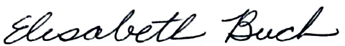

Elisabeth Buck  
President, United Way of Central Iowa