**Jered P. Boley, Applicant for “40 under 40”, Business Record 2019.**

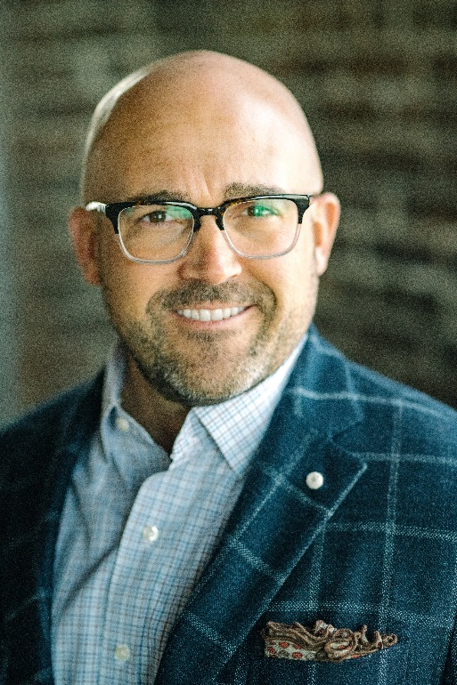

I am the third generation in my family to be a part of a highly successful window and door distributor in central Iowa. My grandfather worked for and owned the local Pella Window and Door dealer in the 1960’s and my father has worked here for forty years, and is now the CEO and sole owner. He has significantly grown the business and has provided many jobs, making a deep impact within our local community. It has always been my dream to follow my father’s example and continue my grandfather’s legacy for the next generation.

I have worked for our family business since I was fourteen years old, working in the warehouse and delivery departments. After I graduated from college, I moved into inside sales, transferred to outside trade sales, managed the retail sales department, and most recently managed the trade and commercial sales of the business. Each department position has allowed me to learn detailed processes, gain confidence, and serve our customers to the best of my ability.

**A few key achievements accomplished in my Pella career are as follows:** I won the individual President’s Club award in 2005 and 2007. This award is given by Pella Corporation to the top ten percent of Sales Representatives across the country.In 2012, my sales team achieved the distinguished President’s Club award. This award is given to only a few Pella sales distributors in the country and is achieved by growth, profitability, and high customer satisfaction rating. Lastly, I won the 2013 Directors Achievement Award from Pella Corporation. This award is given to only a select few managers nationwide who have stood out in their leadership approach, development of new programs that drive success, and significantly grew their revenue year over year**.**

**In January of 2019, I received a promotion to General Manager & Senior Vice President of Prairie Pella, Inc.** I am anaccomplished leader with sixteen years of experience working with a wide variety of clients in the construction, development and remodeling industry. I have been recognized in our industry for outstanding customer service, growth, and profitability. I have **e**xperience in working extensively inner-departmentally with Accounting, Customer Service, Operations, Order Entry, and Delivery.

**I am a member and actively involved in the Des Moines Homebuilders Association**. The Homebuilders Association of Greater Des Moines, chartered in 1944, is a non-profit trade association affiliated with the National Association of Homebuilders (NAHB) and the Homebuilders Association of Iowa (HBAI). The HBA of Greater Des Moines is dedicated to the advancement of the building industry, its members and the communities it serves. This organization also gives back to our local community with several fundraisers each year.

**I am also a** **member of the American Institute of Architects, Iowa Chapter**. The mission of AIA is to serve the AIA Iowa membership by being the voice of the profession of architecture, promoting the value of good design, and advocating for the health and safety of the public.

**I serve on the Board of Directors for Wildwood Hills Ranch of Iowa.** Since 2001, Wildwood Hills Ranch has been committed to helping the children who need it most. Ranch programs prepare around 1,000 at-risk students every year with new life skills, confidence and hope so they can go back into their community and have a transformational impact. We are building a better world, one child at a time. As a member of the board, I am involved in all aspects of this valued organization. I have helped raise funds to expand facilities at the ranch, adding new programs, and ultimately increasing our number of children that we serve each year. Recently we have collaborated with Veterans to bring needed equine therapies to them, to help with their PTSD diagnoses. Wildwood Hills Ranch is truly a one-of-a-kind organization that our community deeply benefits from.

**Advanced Education** In 2016, I made the decision to go back to school to pursue my Executive Masters of Business Administration. I graduated from the University of Iowa, Tippie College of Business in the fall of 2018. I valued this challenge, and learning from my peers in our community; this was a great experience that stretched me and gave me the skills I need to lead our organization today.