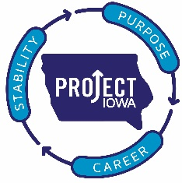**Project IOWA**

1420 Mulberry

Des Moines, IA 50309

515-280-1274

[www.projectiowa.org](http://www.projectiowa.org)

01/09/2018

Business Record

Forty under 40 awards

Recommendation for Leslie Olson

I am proud and honored to nominate Leslie Olson for the Forty under 40 award. I have worked in the non-profit field in Des Moines for the past 20 years and I was very impressed by Leslie the first time I had the opportunity to see her facilitate a workshop. It was a training to help professionals understand the refugee community. Her and her co-facilitator did a very creative and innovative skit that taught participants a lot about issues and how refugees interpret them. I then sought out Leslie to learn more about her and how they had come to create the exercise. I believe it was one of the most impactful trainings I have experienced.

Since that time I have had the opportunity to work with Leslie on various projects and have found her to always be thoughtful and exceptional in her work.

Currently, I am supervising her as she attains her Master of Social Work Degree from the University of Iowa. As an experienced supervisor of students, I believe Leslie is very talented and does and will continue to contribute to Des Moines and the refugee community. It is an honor to work with her and watch her grow and learn. I know we are going to continue to see innovative and dedicated work to improve our community from Leslie Olson. I am proud to call her my colleague.

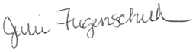

Julie Fugenschuh, L.M.S.W

Executive Director

Project IOWA

[Julie.fugenschuh@projectiowa.org](mailto:Julie.fugenschuh@projectiowa.org)

515-280-1502