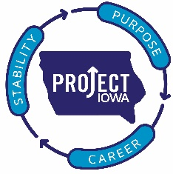**Project IOWA**

1420 Mulberry

Des Moines, IA 50309

515-280-1274

[www.projectiowa.org](http://www.projectiowa.org)

01/10/2018

Business Record

Forty under 40 awards

Recommendation for Melissa O’Neil

I am writing in support of the nominee Melissa O’Neil for the Forty under 40 award. Melissa and I have been in a collaborative relationship working as non-profit leaders to impact change in our community. I met Melissa a few months after she became the CEO of Central Iowa Shelter and Services. Her energy and enthusiasm about her position and the work with residents of central Iowa was contagious. She was working hard to engage as many partners as possible in her quest to make central Iowa a better place for everyone. Melissa and I continued to talk and see how we could work together to end homelessness and increase financial stability. About a year and half ago she began to talk about more than collaboration…she wanted us to co-locate.

Project IOWA and Central Iowa Shelter and Services now collaborate on a daily basis as we are co-located because Melissa had a vision of how we could have greater impact.

I believe Melissa O’Neil is an excellent candidate for this award as her vision and determination will make Iowa a better place for everyone

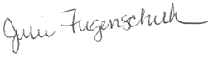

Julie Fugenschuh, L.M.S.W

Executive Director

Project IOWA

[Julie.fugenschuh@projectiowa.org](mailto:Julie.fugenschuh@projectiowa.org)

515-280-1502