January 07, 2019

Ref: 2019 Des Moines 40 under 40 applicants: Krista Turner

40 under 40 Nomination Committee:

As former President and CEO of Aureon HR, I am pleased to offer this letter of recommendation for Krista. In the past 25 years of being in the business of employment and encountering thousands of individuals each year, I rank Krista on the top of my list for exemplifying “can-do” solution-oriented thinking and leadership. It’s rare to see the intersection of a high degree of intellect/competency, professional and personal competitiveness, and compassion and interest for others and community in one individual. They have intersected in Krista.

I have had the pleasure of getting to know Krista over the past 11 years. I’ve had a front row seat in observing her be an instrumental partner in the growth of the Merit/Aureon organization along with growth of those that work under her leadership. In addition to her professional dedication and success, Krista has balanced life well, making time to invest in her family and community.

From my experience with past 40 under 40 award recipients, several of whom represent our organization, I am confident that Krista would carry the recognition with the same commitment level to represent Central Iowa and Des Moines with pride. Krista’s dedication, experience, and passion give her the qualities that set her apart from others. I believe Krista’s career accomplishments and her civic involvement exemplify what it means to be a member of the 40 under 40 class.

I am happy to speak to any committee member and elaborate on my endorsement and recommendation of Krista. My contact information is included.

Best regards,

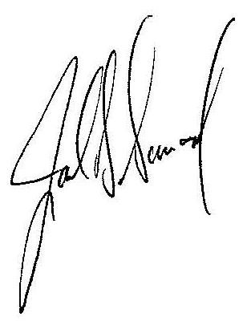

Joel D. Duncan

Former President & CEO

duncan.joel@outlook.com