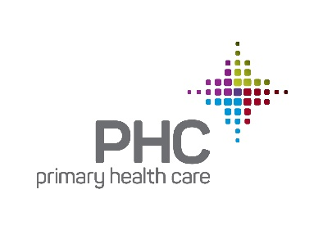

January 10, 2019

RE: Nathan Simpson

To Whom It May Concern:

I am writing this letter in support of Nathan Simpson’s nomination for a Forty Under 40 award. I hired Nathan in 2012 to join the Primary Health Care, Inc. team as a Clinic Director and couldn’t be happier to be writing this letter of recommendation for his nomination.

Nathan began his PHC career as a Clinic Director, where he immediately stood out as a leader who wouldn’t be in that position long. In 2016, Nathan was promoted to the Director of Clinic Operations, where continues to exceed my expectations as he has grown in his position. Nathan is truly my right hand! I don’t know what I would do without him.

Nathan possesses exceptional leadership skills. He has high expectations for himself, leads from the front, and has an amazing work ethic. Nathan works very well with the rest of the executive leadership team and the other leadership team members. He is a respected and valued team member, who offers thoughtful input. Nathan is committed to our patient population, always willing to go above and beyond to ensure our patients are cared for, by modeling PHC’s mission and values on a daily basis.

Nathan would be an excellent addition to the prestigious Forty Under 40. I am thankful every day that he is part of my team. You will feel the same way if you select him for this honor.

With appreciation for your consideration,

Rachel Adams

Chief Operating Officer