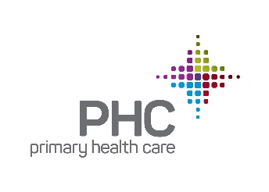

January 4, 2019

RE: Nathan Simpson

To Whom It May Concern:

I am writing this letter in support of Nathan Simpson’s nomination for a Forty Under 40 award. I have worked with Nathan since he started with Primary Health Care, Inc. in 2012 and I am thrilled to be writing this letter in support of his nomination.

During Nathan’s time with PHC, he served as Clinic Director at several PHC clinics in Des Moines before being promoted to Director of Clinic Operations in 2016. In his current role as Director of Clinic Operations, he successfully oversees operations of all PHC medical clinics including 6 full-time and 3 part-time sites and a large number of staff. In addition to this position, he has admirably served his country in the U.S. Army. He is a strong leader; committed, disciplined and passionate about PHC’s mission of caring for low-income and vulnerable people in our service area in Polk, Story and Marshall County. He is respected for his expertise, knowledge and work ethic by his staff, peers and senior leaders. He is always willing to go above and beyond to do what is needed to make sure that staff and patients are cared for, setting an example for staff in living PHCs’ values of integrity, compassion, access, respect and excellence. He has been instrumental in PHC’s growth over the past several years and has led several key initiatives in support of our strategic plan.

Nathan is an excellent and truly deserving candidate for the Forty Under 40 award and I hope that his nomination is given serious consideration.

Sincerely,



Kelly Huntsman

Chief Executive Officer