****

January 6, 2014

To: The Business Record Forty Under 40 Selection Committee

I am writing this letter of recommendation on behalf of Kathleen Riessen, a nominee for the *Business Record’s* 2014 40 Under 40 class. Kathleen is a perfect fit for this distinction because of her passion and service to the marketing community. And she is simply someone that professionals in the Des Moines area should get to know because Kathleen is one of those people that make others around her better through a warm personality and easy-going attitude mixed with youthful insight and wisdom that you just have to absorb.

Kathleen and I have been colleagues for 10 years. We first met when she recruited me to serve on the board of the American Advertising Federation of Des Moines, our market’s professional association serving agencies, vendors and corporate marketers. The AAF of Des Moines serves the area by lobbying for our industry’s interests, providing on-going education and professional development for students and professionals, and creating important public service and networking opportunities.

Kathleen has been an active member in the AAF since she was an Iowa State University student a dozen years ago. She progressed from volunteering as a student to eventually serving as the board president, leading a charge six years ago to reposition the organization to better engage our members and provide value to area advertising agencies.

Following what was already a significant commitment to serve locally, Kathleen went on to become the first AAF member from Des Moines in quite a long time to be elected to the AAF District 9 (Iowa, Missouri, Kansas, Nebraska) board. As the AAF District 9 Governor, Kathleen continued bringing guidance to the AAF of Des Moines. She has been involved on the district and national level by leading education initiatives for university students, promoting the excellence of advertising in the Midwest and continuing to advocate for our industry all the way to Washington.

As I serve my second term as AAF of Des Moines Board President, I am grateful to have met Kathleen and formed a rewarding friendship. She encouraged me to volunteer, but more importantly she has encouraged me to be a leader, motivated me to make a difference and shown me that passionate, nice people succeed in this industry. I admire her commitment to the industry and her ability to grow professionally through the leadership she has volunteered. She is a deserving candidate.

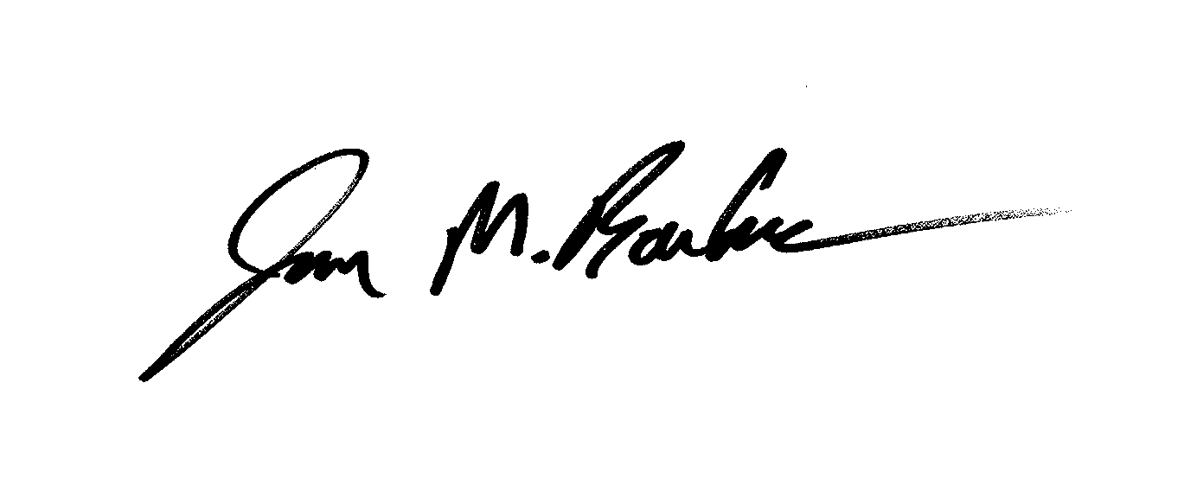Sincerely,

Jason M. Boucher

Vice President of Client Service

ZLR*IGNITION*