December 10, 2013

Mr. Jason Swanson

Director of Operations

Business Publications Corporation

100 4th Street, Ste. 100

Des Moines, IA 50309

Dear Jason and Members of the Business Record’s “*40 under 40*” Selection Committee:

Please accept the enclosed application and nomination for Ms. Andrea Jansa as candidate for the Business Record’s 2014 class of “*40 under 40*”.

I first met Andrea when she became a volunteer for the Chrysalis Foundation, where I served as Director of Development and Communications. Since that time, Andrea has been involved in many community activities.

*Passionate* is an accurate adjective for Andrea and she defines what a “do-er” is by Iowa standards and she’s exactly what you want in a volunteer. Whatever the task you know she’ll put forth 100% plus effort and get the job done, whether it be for the Junior League, Orchard Place or Young Professionals Connection (to name a few). I know that that same passion will lead her to continued success into the future.

I hope that you will give sincere consideration to Andrea for this nomination to the class of 2014. Should you have any questions, please don’t hesitate to contact me. I may be reached at (515) 238-1166 or [leslielgarman@gmail.com](mailto:leslielgarman@gmail.com).

Sincerely,

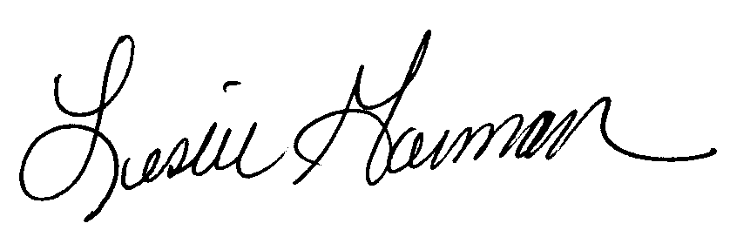

Leslie L. Garman, CFRE

January 6, 2014

The Business Record

Attention: Forty Under 40 Selection Committee

The Depot at Fourth

100 Fourth Street

Des Moines, IA 50309

Please accept this nomination for Andrea Jansa for the 2014 Forty Under 40 Class.

I have had the pleasure of getting to know Andrea over the past three years through the Greater Des Moines Partnership’s Young Professionals Connection (YPC) Board of Directors, the formation and growth of Lead Like a Lady, and also working together on mutual clients through her work with LS2 Group.

Andrea’s accomplishments and work history are impressive, but so is her level of dedication to her community in serving through non-profits and various membership organizations. She has maintained a high level of involvement, but more impressive that she has taken on a leadership role in most everything she does. This comes naturally for her, and she is frequently called upon to contribute her knowledge and expertise, as well as extensive connections.

* Business Acumen—Andrea has extensive expertise in government relations through her diverse work with the Iowa House of Representatives, advocacy and policy with LS2 Group, serving with Iowa House Democratic Leader Staff, as a Field Organizer for One Iowa, a Campaign Manager for Tim Hoy (State House), and a legislative clerk for Senator Rob Hogg. Through this work she has helped pass legislation, overseen day-to-day operations of committees and councils, and lobbied for some very high profile clients. She has covered the gamut of experiences in government and is a known “go-to” in the community for how to get things done.
* Commitment to Philanthropy and Leading by Example—Andrea serves as a Board Member for several very respectable organizations in Des Moines including Des Moines Park & Recreation, Orchard Place, New Leaders Council, Dawn’s List, and YPC.
* Ongoing Professional Development—Andrea graduated from the Greater Des Moines Leadership Institute in 2013, is very involved with the New Leaders Council, and Junior League of Des Moines.

With unprecedented change and an escalating complexity of issues facing our state, the need for highly effective leaders in business, government, and community has never been greater. Andrea is a young professional that is truly making the world a better place every day.

Please feel free to contact me with any questions: [mruble01@msn.com](mailto:mruble01@msn.com) or 515-971-9995 cell.

Thank you for considering Andrea Jansa for the 2014 Forty Under 40 Class.

Sincerely,

Megan Ruble

Senior Account Manager

Wellmark Blue Cross & Blue Shield of Iowa

December 26, 2013

Selection Committee

Forty under 40

Des Moines Business Record

100 4th Street

Des Moines, IA 50309

To whom it may concern:

Andrea Jansa is being nominated for the *Forty under 40* award and I would like to very much endorse this nomination.  You can see by the nomination that she is involved in many community and civic affairs. Having had the opportunity to work with Andrea I can tell you that she is very professional in her work, is a very hard worker and does have an excellent reputation at the capitol.  Andrea is very deserving of this recognition.

Respectfully,

Cal Hultman  
Hultman Company  
855 East Court Avenue  
Des Moines, Iowa 50309

hultmanco@gmail.com  
Cell:     515-979-6643  
Office:  515-244-4480