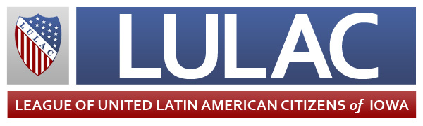

Jan. 10, 2014

On behalf of the Iowa League of United Latin American Citizens, I am proud to nominate Adriana Flores for the Business Record’s 2014 Forty under 40.

Adriana has strived to make a positive influence in the Latino community since she was in high school more than 15 years ago, and has spent countless hours working with youth and volunteering. This continued into adulthood through her employment, her volunteer work and her service as part of various organizations that help promote, and advocate for and on behalf of Latinos.

Much of Adriana’s focus has been on social services, helping youth and victims of domestic violence. She has served as executive director of LUNA (Latinos Unidas por un Nuevo Amanecer) since 2008. In this capacity, she has facilitated trainings and presentations on domestic violence, child abuse, ethics, confidentiality, diversity, prevention and self-care. Adriana, herself, is a survivor of domestic abuse, which has enabled her to develop a connection with the individuals with whom she works at LUNA. She feels strongly about helping them get out of harmful situations and advocating on their behalf.

Adriana also serves as a mentor to a young Latina through the Latina Leadership Initiative of Greater Des Moines. She understands the importance of having a mentor: A case worker took her under his wing when she was in high school and helped her become the first person in her family to attend and graduate from college. His compassion inspired her to want to work with youth, specifically the Latino community.

Adriana has received many accolades for her work in helping Latino youth and Latinas, including a Leadership Fellowship through the Women of Color Policy Network. She was also awarded for her heroism – The Des Moines School Board recognized her and others for helping a single-mother and her four children escape their home during a fire at the trailer park in which they lived.

It is because of these reasons and many more that I believe Adriana Flores deserves to be named one of the Business Records’ Forty under 40.

Sincerely,

Joe Enríquez Henry,

Iowa LULAC State Director

*\*LULAC is a 5-1(c)(4) organization. Any and all contributions or gifts to the organization are not deductible as charitable contributions for federal income taxes.*

Joe Enríquez Henry

*State Director*

Michael Reyes

*Deputy State Director*

G.G. Sierra

*Immediate Past State Director*

Kirstin Shaw

*State Secretary*

Toni Robertson

*State Treasurer*

Melissa Walker

*State Director for Publicity*

Mary Campos

*Deputy State Director for the Elderly*

Teresa Garcia

*Deputy State Director for Women’s Activities*

Antonio Cedillo

*Deputy State Director for Youth Activities*

Visit www.lulaciowa.org

Visit www.lulaciowa.org

**2463 E Highview Drive, Des Moines, Iowa 50320 • 515-208-7312**

Union Made in Iowa