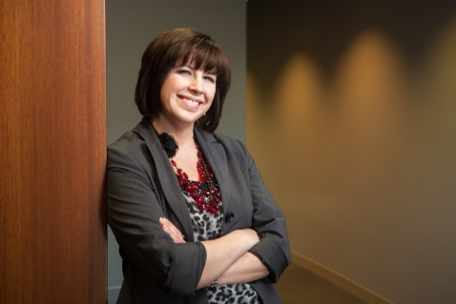

BIOGRAPHY

Before joining Bearence Management Group Stephanie Bolles, was a Regional Vice President for Householder Group Financial Advisors, and previously served as a Managing Principal and subsequently a Branch Manager. Stephanie has spent her entire career helping her clients achieve their goals and objectives. She has made a lifelong commitment to helping people meet their financial needs. Stephanie holds the following securities registrations: Series 6, 7, 63, 65, and 26 (a registered principle). She is also licensed for life, health, disability, and Long Term Care. Stephanie has completed her coursework to sit for CFP Board Exam. These licenses and credentials allow her to handle the diverse vehicles and counseling her clients often need to meet their goals. She is also a Registered Representative with Securities America, Inc.

As an Investment Advisor Representative Stephanie specializes in developing and implementing financial and estate plans for private clients and businesses. She incorporates a comprehensive holistic approach to financial planning from basic retirement, college planning, and family protection, to advanced tax advantaged investing strategies, minimizing income and estate taxes, and multi-generational wealth management.

Stephanie was born and raised in Connecticut, where she attended the University of Connecticut and received her Bachelor of Science Degree. She subsequently received her Certificate in Financial Planning from the College of Financial Planning. She has been married to her husband, Derek for 14 years and they have a beautiful 10-year-old daughter, Samantha. Stephanie recently moved to Iowa January 2012 by choice with no family or job connections, just wanted to move to the Des Moines area, purchasing her home in Van Meter. Stephanie and her family were looking to move to a small city with strong community involvement, a focus on traditional family values, and excellent primary and secondary educational opportunities. The Des Moines area was a perfect fit. She is an ambassador to the city, loving the move and planning to stay indefinitely.

Stephanie quickly became involved in local networking and community involvement. Upon doing so she soon learned Des Moines Women Business Owner community is substantially low compared to rest of the country and has made it her mission to bring her expertise to Women Business owners to ensure these businesses, owners, and employees have the best success possible.

Stephanie is a member of the National Association of Professional Women, a national networking group specifically focused on the success of Women Professionals. She is also a member of Des Moines Young Professionals.

Stephanie is a member of Iowa ABI and sits on the tax committee. She is also involved with the mentor program the Leadership Institute with ABI and attends many of the events, as the firm she affiliates with is a corporate sponsor.

Stephanie also feels all individuals young and mature have a civic responsibility and has chosen to volunteer her time in many ways. One of the charitable organizations Stephanie is involved is the Animal Rescue League. Stephanie and her family are passionate about animal rights having 4 rescue dogs, 2 rescue ferrets, and a 120 gallon fish tank. For this reason she thought it would be a great charity for her to introduce her 10 year old daughter to, and they volunteer and visit the animals at ARL often.

Shortly upon moving to Iowa Stephanie became involved with the United Way’s Financial Literacy Network which provides free financial educational workshops and money coaching to underprivileged families.

Stephanie and her family feel when you live in a very small town like Van Meter, it is vital to volunteer your time and skills to keep the community strong. Stephanie has a long soccer history of her own and sits on the City of Van Meter Recreational Soccer Board and is a Youth Soccer Coach.