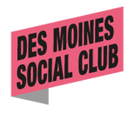

January 10, 2014

To Whom It May Concern:

I am writing to nominate Jami Graves for the prestigious 40 under 40 award. Jami exemplifies exactly what I believe this award to strives to do – honor those who are helping our community grow.

Jami is unique in that not only is she working everyday to expand the cultural community in Des Moines through her photography and marketing efforts, but also she is a selfless advocate for so many other hardworking young professionals.

I have seen this first hand as Jami was a board member of DMSC for the past 3 years and was a driving force helping us move into the Firehouse. All the while Jami was working with myself and dozens of other artists to formulate how we would provide space for so many eager creatives. Jami seems most happy when she sees others achieve, and of course when she is able to do so herself.

Jami is most deserving of this award, and I highly recommend her to help represent the cultural scene here in Des Moines. We are lucky to have her working here.

Respectfully,

Zachary Mannheimer
Executive Director
Des Moines Social Club

