John Landon  STATE REPRESENTATIVE  Statehouse: (515) 281-3221  e-mail –john.landon@legis.iowa.gov  HOME ADDRESS  525 NE Stone Valley Dr  Ankeny, IA 50021  Ph. 515-249-0348 | 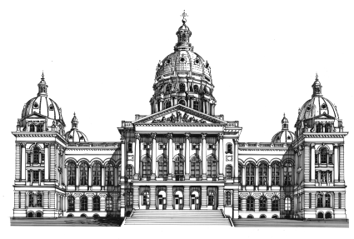  House of Representatives  State of Iowa  Eighty-Fifth General Assembly  STATEHOUSE  Des Moines, Iowa 50319 | COMMITTEES  Commerce  Human Resources  International Relations  Transportation  Ways and Means, Vice Chair  APPROPRIATIONS SUBCOMMITTEE  Transportation, Infrastructure, and Capitals

December 30, 2014

To Whom It May Concern:

It is my great pleasure and honor to wholeheartedly recommend Gabriel Glynn to be selected as one of the 40 Under Forty recipients. I have personally known Gabriel for several years and would like to speak of his many qualifications.

Gabriel is working to transition our communities’ uptown area into a destination for business growth and recreational opportunities. His leadership is providing the energy and direction needed for many exciting projects.

In recognition of his leadership abilities Gabriel has been chosen to receive many special awards including the coveted Entrepreneur of the Year Award at the DMACC Small Business Awards. He serves on many boards in our community, among them Ankeny Young Professionals, Cultural Arts Board for the City of Ankeny and the Greater Des Moines Integrity Network.

Family is very important to Gabriel. Together with his wife Amanda, they have two young children.

Our community is fortunate and proud to have Gabriel Glynn as a young and influential leader. I am very pleased to provide this letter of recommendation in recognition of Gabriel’s energy, dedication and abilities in making our community a better place to live and work.

Sincerely,

Rep. John R. Landon
Iowa House District 37

