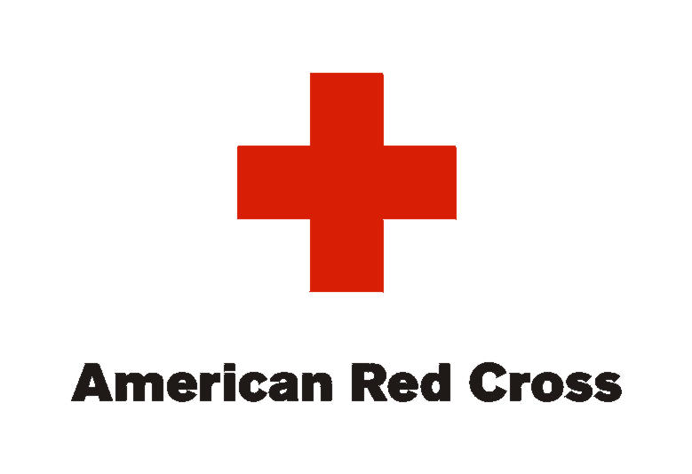
American Red Cross serving Iowa
Central Iowa Area
2116 Grand Ave.
Des Moines, IA 50312

December 22, 2014

Des Moines Business Record
Forty under 40 Award
100 4th Street
Des Moines, Iowa 50309
Members of the 2015 Forty under 40 Selection Committee:

It is with great pleasure that I recommend Shawn Russell for the 2015 Forty under 40 award. For six years Shawn has volunteered for the American Red Cross in central Iowa assuming progressively responsible leadership positions.

I first met Shawn when she served on our Heroes of the Heartland Event Committee working closely with Red Cross staff to ensure a successful signature event. With her help we have raised more than $1,000,000 to support the Red Cross mission. She uses her knowledge and experience of marketing to build and maintain a positive image of the honored heroes and the Red Cross. Currently she serves as Chair of the Promotions Committee leading social and broadcast media strategies promoting the event.

Two years ago Shawn was recruited to serve on the Board of Directors (in part, due to her stellar work on Heroes of the Heartland) and she has made a positive impact by bringing her fresh, innovative ideas to the work of the board. She was named to the Executive Committee of the Board this year working with Board leadership to manage mission delivery in central Iowa.

Shawn is passionate about the mission of the American Red Cross. She is a champion for our cause realizing that brand management and marketing are critical to the success of the organization. She is a valued and trusted volunteer leader for the American Red Cross.

I hope you join me in recognizing Shawn’s efforts and her outstanding contributions. I feel so fortunate to work closely with her and it is my honor to nominate her for this prestigious award.

Sincerely,
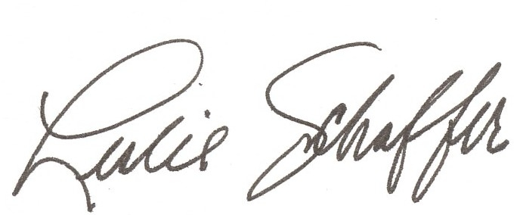

Leslie Schaffer
Regional Executive
American Red Cross serving Iowa

