|  |
| --- |
| SCOTT REISTER * KCCI * FORTY UNDER 40 |

January 8, 2015

To Whom It May Concern:

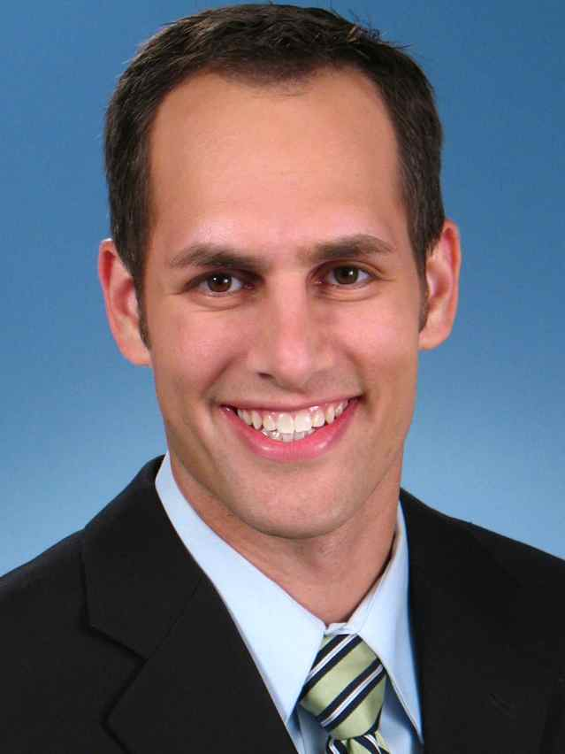

Every day I strive to share my passions with others, toward the goal of improving the lives of individuals as well as making my community a better place for all to live.

I am honored to be a part of the reporting team at KCCI, one of the top-rated stations in the nation, as a Sports Anchor and Sports Reporter. I love producing sports stories that will reach and touch people’s hearts, and am gratified that my creative style of anchoring catches the attention of sports and non-sports fans, alike.

To have been given the opportunity to make an impact on people with my stories is both gratifying and humbling. Recently, a story that I did about a star player giving up a touchdown went viral (<http://www.kcci.com/sports/star-player-shows-hes-the-ultimate-teammate/29398352>), and winning numerous local and regional awards have taken many of my stories to a national audience via various CBS platforms. I receive affirming letters from viewers, as well, which is, indeed, the greatest reward of all. One such letter can be seen [here](https://www.facebook.com/ScottReisterKCCI/photos/a.1482080312023559.1073741828.1419253588306232/1552813871616869/?type=1&theater), and my body of work can be found at <http://sreister.wix.com/scottreistersports>.

I am an enthusiastic supporter of Prevent Blindness Iowa, helping to raise funds, participating in their events, and serving on their Board of Directors. I publicly endorse and privately support Special Olympics, Food Drives, Urbandale’s Fourth of July Celebration, and the Urbandale Library. I speak regularly to schools and other groups about careers in the media, I am active in my synagogue, and I have “celebrity judged” everything from chili to pet rocks.

Thank you for your time and your consideration for Forty under 40.

Sincerely,

Scott Reister

KCCI Sports

515-661-1979

Resume on next page

|  |
| --- |
| SCOTT REISTER * KCCI * FORTY UNDER 40 |

# Experience

## Sports Anchor/Reporter KCCI – Des Moines, Iowa 2009-present

* Anchor, live report, shoot sports for markets top-rated station
* Travel around the nation covering Big 12, Big Ten, and Missouri Valley Conference sports
* Manage extensive local coverage during weekend
* Develop, shoot, write award-winning stories which have been aired nationally on CBS News.
* Update station website and maintain strong social media presence

## Sports Director, KNDU-TV – Kennewick, WA 2006-2009

* Produce/anchor/report daily sportscasts for market’s top-rated station
* Shoot/edit/write award-winning features
* Host/Reporter for live sporting events on Spokane Sports Television

## Sports Anchor/Reporter KXXV-TV – Waco, TX 2002-2006

* Helped increase ratings to second-highest in market
* Host/produce 30-minute weekly high school specials
* Spent 2002 leading one-man satellite office in College Station, TX

# Education

## University of Texas at Austin 1998-2002

* Bachelor of Journalism with Broadcast News Major
* Business Foundations Program
* Sports Director and play-by-play voice of student TV station
* Sports writer for student newspaper, *The Daily Texan*
* Dean’s List 1999, 2001
* Sigma Alpha Mu Fraternity

# Volunteer

* Board Member for Prevent Blindness Iowa
* Tifereth Israel Synagogue
* Guest speaker at schools and organizations
* Special Olympics Washington

# Awards

* Board Member for Prevent Blindness Iowa
* 1st place Sports Feature - Iowa Broadcast News Association (IBNA) - 2013
* Award of Merit - Northwest Broadcast News Association, 2013
* 1st place Sports Feature - IBNA - 2012
* 1st place Sports Feature - Eric Sevareid Regional Award - 2011
* 2nd place Sports Feature - IBNA - 2011
* 3rd place Sports Feature - IBNA - 2011
* Nominated for a Midwest Regional Emmy - 2011
* 3rd place Sports Feature - IBNA - 2009
* 2nd place Sports Story - Society of Professional Journalists (SPJ) Region 10 - 2007
* 3rd place Sports Story - SPJ Region 10 - 2007