
January 8, 2015

40 Under 40 Review Committee
Des Moines Business Publications
100 4th St.
Des Moines, IA 50309

Dear Review Committee,
It has been my honor and privilege to work with Lisa Pringle-Chmelka as a member and volunteer with the Urbandale Chamber of Commerce. Lisa has consistently shown leadership in working with the Chamber as the volunteer coordinator for the Wild West golf tournament. In addition, Lisa has previously participated in our largest annual fundraising effort, raising necessary dollars for our organization.
Lisa dedicates time to the Children Cancer Connection organization as a committee member, is a Board member of the Polk County I Club, Leukemia/Lymphoma Man/Woman of the Year activities and more.
Lisa exemplifies professionalism and is talented in all aspects of her career at Career Search Associates. For all the reasons above, I believe Lisa would be a perfect candidate to award 40 under 40.
Thank you for your time and consideration.

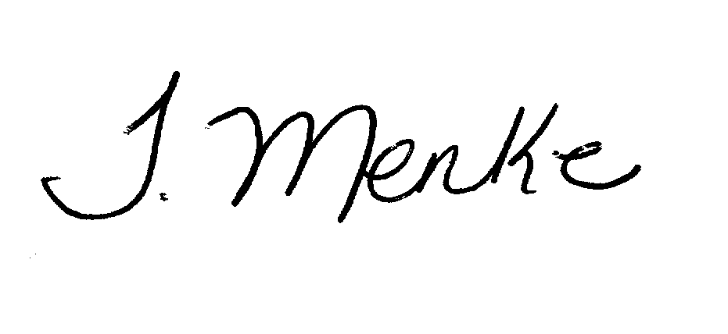
Best Regards,

Tiffany Menke, IOM
President
Urbandale Chamber of Commerce
2009 Recipient of the 40 Under 40 honor

