I have had the pleasure of working with Emily Bahnsen for more than ten years, and as her direct supervisor for more than five. She started out as an intern and worked her way to one of the top leadership positions in the institution. Since being named Development Director, Emily has successfully completed the Art Center’s major fundraising campaign, *Hands On, Des Moines* which raised money for needed capital improvements. She has grown the Development Department from three to five full-time staff members, implemented a planned giving program, engaged dozens of new corporate and individual supporters, and has increased donor support and member groups. In each of the five years she has been Development Director, she has surpassed every fundraising goal helping to not only support the Art Center’s education, outreach, and free admission programs, but to expand them. For example, fourth grade tours have increased from five to seven school districts and outreach had increased from three partnerships to 15 providing healing through art education and experience to those who would not otherwise have those opportunities.

Emily represents the Des Moines Art Center and engages in the community in a professional and positive manner. I highly recommend Emily for the 2015 class of Forty Under 40.

Jeff Fleming, Director

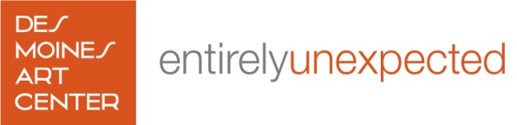

4700 Grand Avenue Des Moines, Iowa 50312

515.277.4405 desmoinesartcenter.org