January 9, 2015

Forty under 40 Committee

100 Fourth Street

Des Moines, IA 50309

Dear Forty under 40 Committee:

It is a pleasure to share my support for Trina Flack as a candidate for Greater Des Moines and *Business Publications* Forty under 40 Award.

Trina has been an associate at the CVB since 2008. She was hired as a Sales Manager but then was quickly promoted, due to her exemplary work, to National Sales Manager. She is responsible for enormous increases in booking many new conventions to our area.

She is also gifted with many leadership skills, confirmed by her peers as well as the involvement in her community. Trina just finished a term as President of the Iowa Society of Association Executives, is a City of Ankeny Planning and Zoning Commission Board Member, FFA Enrichment Center Committee Member and Westwood Elementary PTO Board Member. Trina’s involvement in these organizations highlights the drive and passion she has to make Greater Des Moines even greater!

I believe Trina Flack would be an awesome candidate for this great program. Thank you for your consideration.

Sincerely,

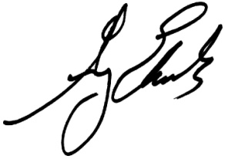

Greg Edwards

President & CEO

Greater Des Moines Convention & Visitors Bureau

Des Moines Area Sports Commission