It is my great privilege to nominate Dr. Martin Gross for the Iowa State University Debbie and Jerry Ivy College of Business innovationEntrepreneur Award.

Martin is the President and one of the founders at Gross-Wen Technologies Inc. (GWT). GWT is a next generation wastewater treatment company that utilized microalgae to cost effectively and sustainably recover nitrogen and phosphorus from wastewater. The byproducts from the process are clean water, clean air, and algae biomass, which can be used to create products ranging from fertilizers to nutraceuticals. As President of GWT, Martin has helped raise over $2.5M in Angel and Seed investments, served as Principal Investigator on $1M in non-diluting SBIR grant funding, applied for and been granted numerous patents, and orchestrated the first commercial sale of GWT’s core technology.

GWT evolved from research Martin performed while pursuing his PhD in Agricultural and Biosystems Engineering at Iowa State University (ISU). His research was supervised by his now business partner, Dr. Zhiyou Wen, a professor of food science and human nutrition at ISU and one of the early pioneers of algal biofilm systems.

Martin Gross and Zhiyou Wen founded GWT in 2014 based on the Rotating Algal Biofilm (RAB) technology. The vertical belt RAB system is a novel and innovative approach to growing algae.

An entrepreneur at heart, Martin was constantly thinking of potential end uses of large-scale production of algae. Initially, he considered growing them for use as the biomass for energy production, as the market for biofuels was growing rapidly. It became apparent rather quickly, however, that this would be too costly with the then-current biomass conversion technology. The solution came from a somewhat unlikely source – the City of Chicago.

In 2013, Gross and Wen attended an algae biomass conference along with 500 of the worlds’ leading algae scientists. At the conference, they met two leading researchers from the City of Chicago Reclamation District. At the time, the City of Chicago knew it needed to improve the nitrogen and phosphorus levels in its wastewater and was considering several technologies, including algae-based solutions. Upon learning about the RAB system, its advantages immediately appealed to the Chicago researchers. Dr. Kuldip Kumar, a Senior Environmental Scientist from the Metropolitan Reclamation District of Greater Chicago, noted, “This is exactly what the industry is looking for to solve our nutrient removal problems. If current tests are successful, this would revolutionize wastewater treatment.”

The City of Chicago, which has the largest water treatment facility in the world, prides itself on being innovative and gaining its approval and advocacy would be a major step toward accepting Gross and Wen’s system. The RAB technology was one of two finalists that Chicago chose to investigate, and now, after two years of building the prototypes and testing their performance, Chicago is considering the purchase of the RAB system.

The RAB technology uses algae to recover nitrogen and phosphorus from wastewater. Algae need five things to grow: nitrogen, phosphorus, sunlight, water, and carbon dioxide. Thus, the RAB process is a highly efficient way to grow algae and at the same time to clean wastewater (see exhibit A below). The technology is relatively simple (see exhibit B). Vertically oriented conveyor belts operate like treadmills pointed skyward, moving very slowly as they rotate through the wastewater. A small portion of the lower part of the belt is being rotated through the wastewater where the algae obtain water and remove nitrogen and phosphorus from the wastewater, while the major portion of the belt is exposed to the air, where the algae obtain sunlight and CO2.

Conventional systems are expensive to operate, as they require pumping air (a source of CO2) into the mix of wastewater being treated. In contrast, instead of dissolving in the water, RAB technology brings the algae out of the wastewater to provide direct contact with both sunlight and CO2, thereby enhancing growth of the algae. Moreover, conventional systems suspend algae in the water requiring a later step in which algae are separated from the liquid. With the vertical RAB system, algae are harvested simply by scraping it from the belts.

In essence, the RAB system makes large-scale/low cost algae farming possible. It draws water, nitrogen, and phosphorus from the wastewater, thus reducing the levels of nitrogen and phosphorus substantially (i.e., by 95%) while allowing the native species of algae already present in the wastewater to grow in the form of a biofilm. Also, as long as the biofilms are healthy (i.e., the algae are getting enough sunlight, water, carbon dioxide, nitrogen and phosphorus), the RAB-grown algae will not produce a foul odor as do algae grown with the conventional approach.

Furthermore, although the primary GWT product is treated water, the RAB technology creates a by-product that has commercial value. The algae biomass has the potential for use in making things ranging from biofuels to fertilizers to bioplastics and more. Therefore, instead of necessitating the expense of disposing of bacterial or chemical sludge produced by traditional water treatment plants, the RAB technology produces a byproduct with commercial value, thus offering a potential revenue stream that can offset some of its cost.

One of the nation’s (and world’s) largest and growing problems is water quality. Significant water pollution has been occurring in the United States because of increasing levels of nitrogen and phosphorus. Whenever anyone uses detergent, discards food in the garbage disposal, or flushes the toilet, they are sending water that contains nitrogen and phosphorus to the municipal water treatment facility. Closer to home, a great deal of food processing goes on in Iowa and all of the industrial water used to process that food goes either into a municipal or an industrial water treatment plant. Additionally, a growing Hypoxic zone in the U.S. Gulf Coast region is growing because of nitrogen and phosphorus that leaves farmland and enters waterways that empty into the Gulf, a process that ultimately costs fisheries hundreds of millions of dollars in lost revenue each year because of fish kills.

Although fertilizer runoff is the primary culprit in problems such as in the Gulf pollution, pollution from industrial and municipal wastewater also contributes. As a result, industrial firms and cities are becoming subject to stricter federal and state regulations regarding nitrogen and phosphorus discharge. Iowa has established new water quality standards (“new permits”), with the early focus on larger cities. Very few of the 100 largest cities in Iowa have the necessary infrastructure to be in compliance, and the situation is even more problematic for the many smaller communities that will soon need to comply. It is estimated that, nationally, municipalities will need to invest $45 billion in new or revised treatment facilities to meet new Environmental Protection Agency standards. The estimated cost in Iowa alone is over $1 billion. Please view the GWT video (link found in Exhibit C).

Fortunately, Iowa State University was in the process of expanding its support of university entrepreneurs and innovators who were interested in commercializing their intellectual property, whether in the form of starting a new company, developing a new product, or licensing a new technology. Martin was extremely interested in making GWT a viable company, but the gap between the business and academic worlds is a common obstacle to university research-based startups. Scholars and scientists who break new ground often lack the inclination, means or time to market their innovations, and aspiring academic entrepreneurs often lack the business experience, market connections, or capital to take the leap.

In the early stages of developing the RAB technology, Martin had benefited from several existing ISU programs and facilities, including the Pappajohn Center for Entrepreneurship, the Bio-Century Research Farm, and the Center for Crops Utilization Research incubation program. In the summer of 2016, GWT joined the first cohort of companies in the new ISU Startup Factory, a 52-week super accelerator that provides a structured “curriculum” during the first 26 weeks and customized support for each individual company during the second 26 weeks. The curriculum, which is delivered by subject matter experts and successful entrepreneurs, consists of three components: customer discovery, overview of essential business and management knowledge, and preparation for pitching to investors. The ISU Startup Factory has created a network of teachers, mentors, and investors that help guide the emerging companies, provides office and collaboration space during the program, and assists companies with forming their management teams.

Martin is a natural leader. His eleven part-time and full-time employees continue to innovate. In 2018, Martin led his company to attain a $2M investment and attained regulatory approval for deploying the RAB technology in Iowa. In 2019 Martin and his team secured GWT’s first commercial sale in the city of Slater, IA. Martin has been able to successfully adapt from being a scientist/engineer into a leader for GWT. Currently Martin gives back to Iowa State University by teaching a course in entrepreneurship which focuses on training graduate students in science and engineering what it is like to be an entrepreneur.

Iowa’s Governor, Kim Reynolds, calls GWT “an Iowa homerun.” Martin developed GWT at ISU, the investors are Iowans, GWT’s RAB system is manufactured in Iowa, and small Iowa municipalities are GWT’s first customers.

I’ll close with an accomplishment from 2017. Martin led the team to win $25,000 and the top prize at the 2017 Pappajohn Entrepreneurial Competition. On the next page is the picture taken at Drake University of the management team, Mr. Pappajohn, and Governor Reynolds. Martin is at the far right in the picture.

Respectfully submitted,

Dave Furbush (515-778-7889)

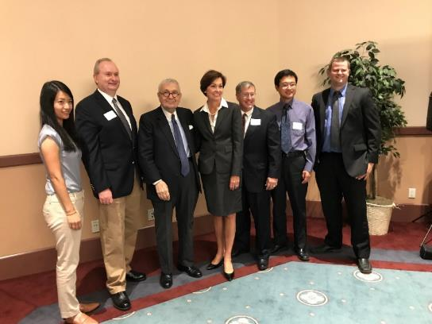

**Exhibits**

**Exhibit A**

**GWT Value Proposition**



**Exhibit B**

**RAB Technology Images**



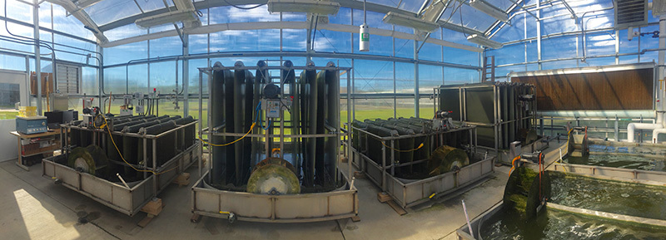

**Exhibit C**

**GWT’s Video**

<https://www.youtube.com/watch?v=fuY2TFyL4Aw>

