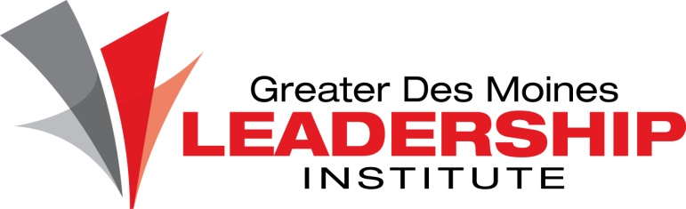

Des Moines Business Record

RE: Meredith Emerging Woman of Influence Nomination for Amy Jennings

Dear Women of Influence Selection Committee,

I would like to provide a letter in support of Amy Jenning’s nomination for consideration as the 2016 Meredith Emerging Woman of Influence. I have had the pleasure of working with Amy for the past four years through her role as the Executive Director of the Greater Des Moines Leadership Institute.

During my time serving on the Board and as the Board Chair for the Institute I have witnessed Amy take us from an organization well known for one program to *the* premier leadership development organization in Central Iowa, if not the state. Amy’s guidance, vision, and drive have helped us double our program offerings, strengthen our community partnerships, and increase our dues paying members. As a “leader of leaders”, she uses her signature style to collaborate with (and direct!) a group of 75+ volunteer Board and committee members, while always striving to better herself. I am excited to see where she will take the Institute. Under her guidance I know the sky is the limit.

In addition to her leadership of the Institute, Amy has taken on a leadership role within the Regional Leadership Council. The Council, which brings directors/leaders of various leadership development programs together to share best practices, learn from one another, as well as foster collaborations, needed a leader and Amy stepped in to fill that gap. She regularly mentors the other program directors and was instrumental in bringing the Association of Leadership Programs’ Midwest Regional Conference to Des Moines in 2016. The Conference will place the Institute on a national stage and will highlight Des Moines in the process.

Amy spends nearly every free moment she has outside the Institute on developing herself as a community leader and helping create positive change in the metro. She impacts many different nonprofit organizations through her volunteer work, including the Water Works Park Foundation fundraising committee, Center on Sustainable Communities (COSC), and the YMCA Healthy Living Center. She is truly an asset to the Institute and to our community as a whole, thus I am happy to contribute to her nomination for this year’s Meredith Emerging Woman of Influence honor.

Sincerely,

Jenna Ekstrom

Board of Governors Chair, Greater Des Moines Leadership Institute