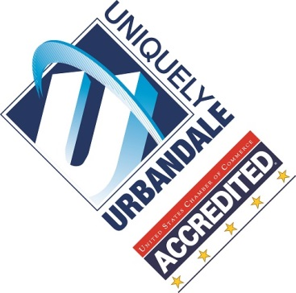

May 21, 2019

Women of Influence Review Committee

Des Moines Business Publications

100 4th St.

Des Moines, IA 50309

Dear Review Committee,

As a 2017 Women of Influence honoree, I am writing this letter to recommend the selection committee consider Amy for the Emerging Young Leader honor.

It has been my honor and privilege to work beside Amy Eaton as a member, Director of the Board and volunteer with the Urbandale Chamber of Commerce. Amy has consistently shown leadership and influence working with the Chamber as a past-chair of the genYP young professional’s leadership team, a director on the board, marketing committee chair and volunteer on a number of committees, including fundraising through our Total Resource Campaign, where she quickly became one of our top sales earners.

Currently, Amy serves as the Director of Marketing and Strategic Development for Women Lead Change. She exemplifies professionalism in her career and volunteer activities. Her passion, honesty and genuine, magnetic personality are unique.

For all the reasons above, I believe Amy Eaton is the perfect candidate to be honored this year as an Emerging Young Leader. Thank you for your consideration.

Best Regards,



Tiffany Menke

President, Urbandale Chamber of Commerce

2017 Women of Influence