

May 20, 2019

To Whom It May Concern,

I am writing to recommend Liz Lidgett as the Business Record’s 2019 Meredith Emerging Woman of Influence. Liz has a passion for making the world around her more vibrant, colorful, and inspiring, and she is doing just that in Des Moines.

In 2013 Liz founded Adore Your Walls, an art advisory service that helps people find art they love for any budget or space. She has managed and curated both corporate and private art collections, worked on installations at numerous restaurants, and commissioned countless mural projects throughout Des Moines. Her work has gained national attention, too. She has been featured in *Martha Stewart Living*, *Better Homes & Gardens*, and *Apartment Therapy*, and just last year, Reese Witherspoon’s *Hello Sunshine* featured Liz in a video series featuring several other Midwest entrepreneurs.

In May Liz opened Liz Lidgett Gallery + Design in the East Village, which introduces emerging and mid-career artists to a Midwest audience. She is also committed to representing at least 50% women artists to help change the statistics of female artist representation nationwide.

When I moved to Des Moines right out of college in 2007, people would ask what I was doing and where I was living. I would answer “Des Moines,” quickly followed by a rather sizeable eye roll. There were a few things to do and see, but nothing to write home about. Twelve years later, I can’t stop talking about great this place is—and Liz Lidgett’s impact has a lot to do with that. From the vibrant murals I get to see every day on my way to work to the ambiance of my favorite neighborhood restaurants, her passion for art in all spaces in infectious. She believes that art can change lives. And that is exactly what she continues to do in this growing city.

As a CEO, entrepreneur, wife, mother, and friend, Liz has more than enough on her plate. And yet she dedicates numerous hours each week giving back to her community—particularly in the areas of arts and culture. She currently serves as the Young Audiences Chair for the Des Moines Metro Opera, and has been instrumental in engaging new audiences at the Des Moines Art Center, most recently as a board member for Salon 4700 (a member group of the art center that provides in-depth engagement with art and artists) and prior to that as president of Art Noir (a young professional member group). She has also served in a variety of volunteer roles for Kappa Alpha Theta, both locally and nationally, serving as the Recruitment Advisor for Beta Omicron (2010-2012) and as the National Young Alumnae Board Chair (2016 to 2018). And as of May 2019, she was named a Kappa Alpha Theta 35 Under 35, and award which recognizes the most impressive of women for their accomplishments after college.

Liz consistently inspires others by leading with authenticity and grace. She is a champion for women and believes that when we build others up, we all succeed. I can think of no other young woman whose influence I am more thankful for.

Sincerely,

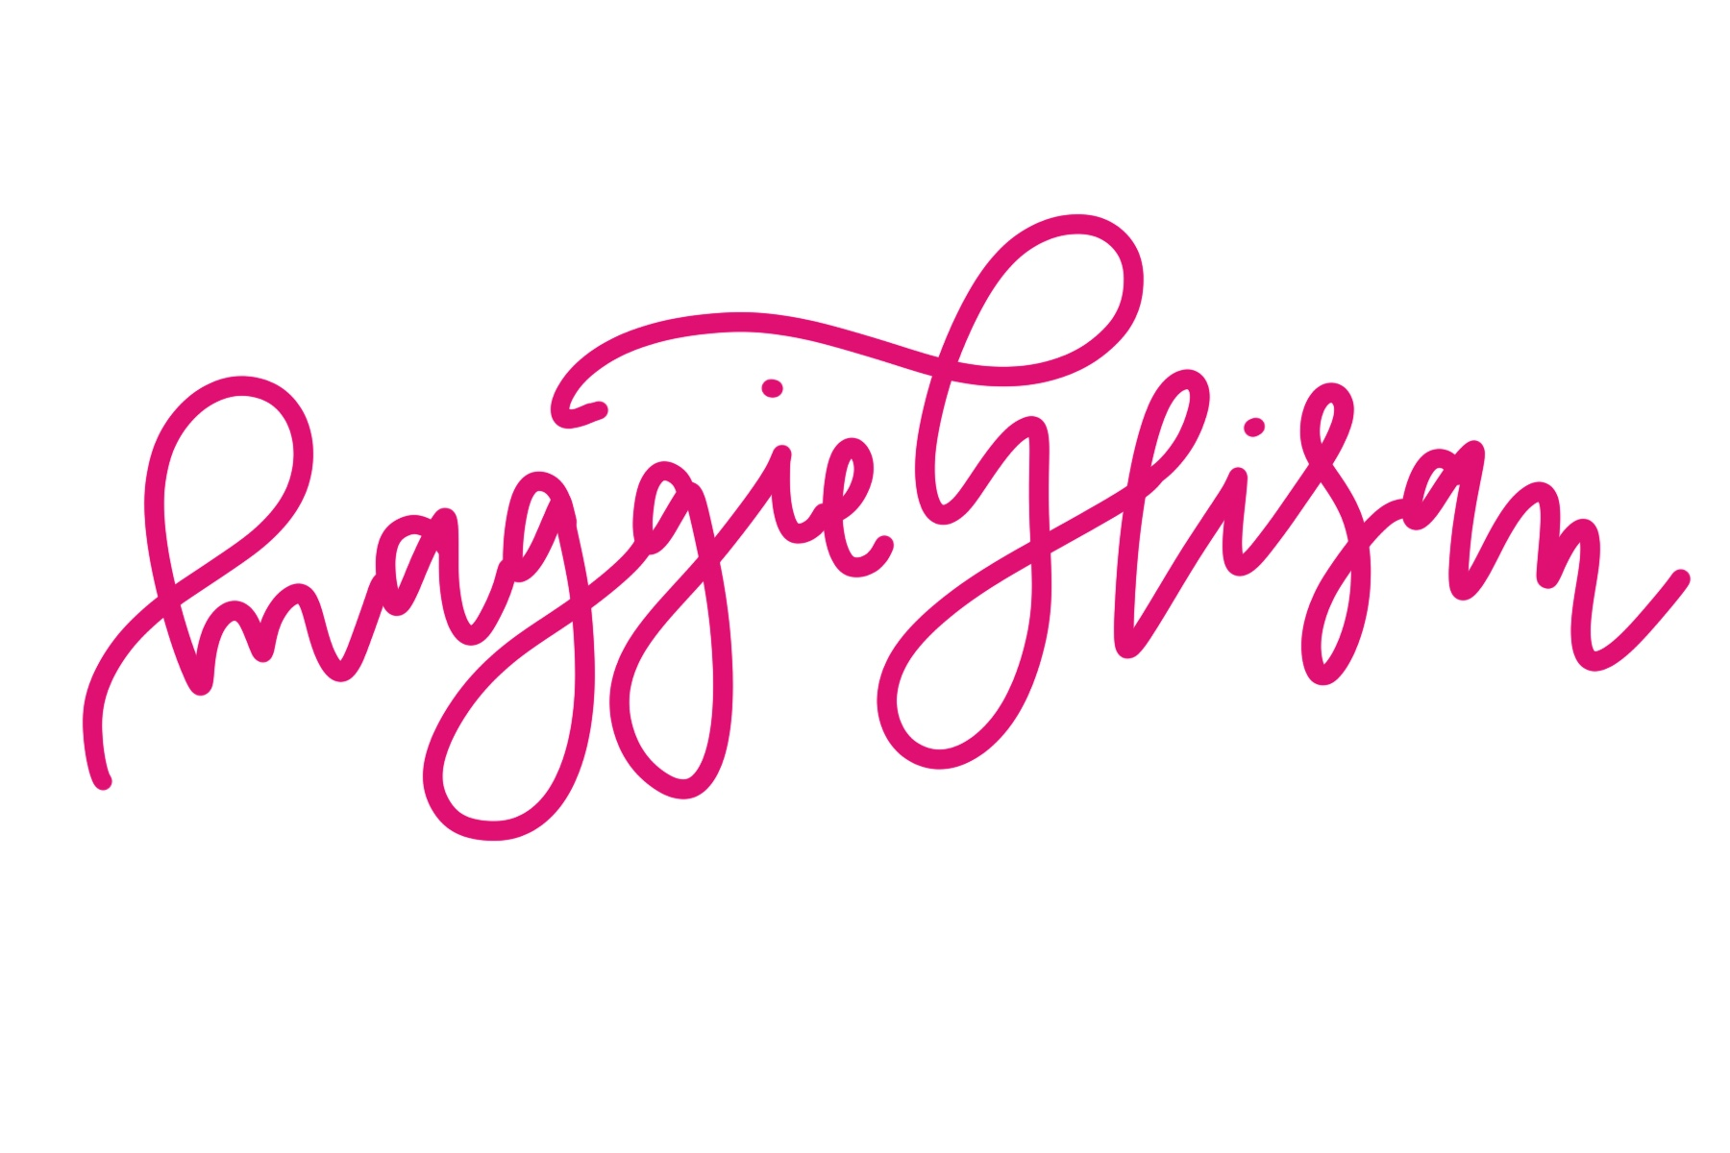

Senior Food Editor, *Better Homes & Gardens* Magazine