Dear Selection Committee,

I am writing in support of Henny Ohr’s nomination for the Women of Influence Award. I have known Henny for nearly five years in both a professional and personal capacity. Simply put, she is one of the most inspiring, hardworking and determined individuals I know. When I think about people in our community who advocate for others, who fight for those without a voice, and who work to make a difference in the lives of those who are struggling, I think immediately of Henny Ohr.

As the former Director of the refugee program at Lutheran Services in Iowa, I saw Henny’s enthusiasm for serving others firsthand. I watched her start a green card clinic and serve hundreds of refugees who were otherwise unable to navigate the complex immigration system. I watched her create manuals and form partnerships with clinics and other agencies to help refugee families better access needed services. I watched her help families navigate systems through crisis; whether it was a death, a child removal, or an eviction notice. Most notably I watched her mobilize and energize Burmese community leaders, struggling to help those from their community, to create EMBARC.

EMBARC is unique because it’s not only charged with helping Burmese families in need, it strives to create and support leaders within the community. While there are service providers in Des Moines who offer a limited scope of services to the refugee community, the needs remain extremely significant, and the involvement of the community itself is limited. EMBARC gives the Burmese community ownership of the supports and services available to families in need and strives to develop solutions from within. Through this model, and the creation of EMBARC, it has been inspiring to watch so many people within the Burmese community find their voice for the first time.

A visit to Henny’s home will tell you the extent to which she is dedicated to this work. Her living room is a mix of toys for her two young children, and boxes upon boxes of donations for families in need. Her car is the same. She is often up until the wee hours of the night responding to emails or working on grants. She takes calls from families at all hours of the day. Whether it’s a crisis at 2am or 2pm, she is frequently on the receiving end of a call for help. She then works to mobilize people from both within the Burmese community and beyond, to rally around those in need. From her husband, to her friends, to her in-laws; anybody who knows Henny is involved in some way.

While Henny works endlessly to address the needs of individuals and families, she also has the unique ability to collect the many barriers and challenges that refugee families face on a daily basis, and then advocate for systemic change. Whether it is availability of English classes, access to interpretation or issues related to housing, Henny defines what it means to not only to advocate for others, but to empower those she is working with to advocate for themselves.

It my great pleasure to recommend Henny Ohr for this award. I can think of no one more deserving.

Sincerely,

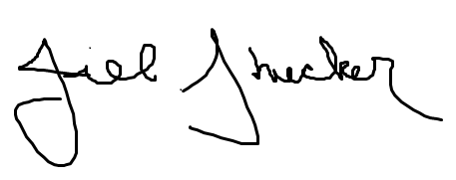

Jill Stuecker