June 4, 2014

Des Moines Business Record
The Depot at Fourth
100 Fourth Street
Des Moines, Iowa 50309

Re: Nomination of Kathryn Dickel, Emerging Woman of Influence

Dear Selection Team:

I met Kathryn Dickel in the early 2000’s as she was just starting her career as a business owner. I had the good fortune of reconnecting with her late last year as a collaborator on the Des Moines Water Works Park renovation. I am please to recommend that you select her as the first Emerging Woman of Influence.

Leaders, emerging or established, share several common traits. In the interest of brevity I’ll only address a few here. The first trait Kathryn inhabits is the attraction and willingness to embrace a challenge. I’ve seen Kathryn take on aggressive timelines, sensitive dialogs and complex logistics with not only advance skill but with passion. She simply thrives in challenging and complex situations.

The second common trait is the ability to seek and accept guidance. For leaders, particularly emerging ones, this is the real hallmark of leadership. The ability to balance the passion for challenge and engagement with an ability to reach out and accept guidance is a skill all good leaders possess throughout their careers. Kathryn has embraced this balance by surrounding herself with mentors and peers she consults with often -- to the benefit of the Water Works Park project, and indeed every aspect of her life, both personally and professionally.

It is for these reasons that I believe Kathryn is an excellent choice as your Emerging Woman of Influence.

Sincerely,
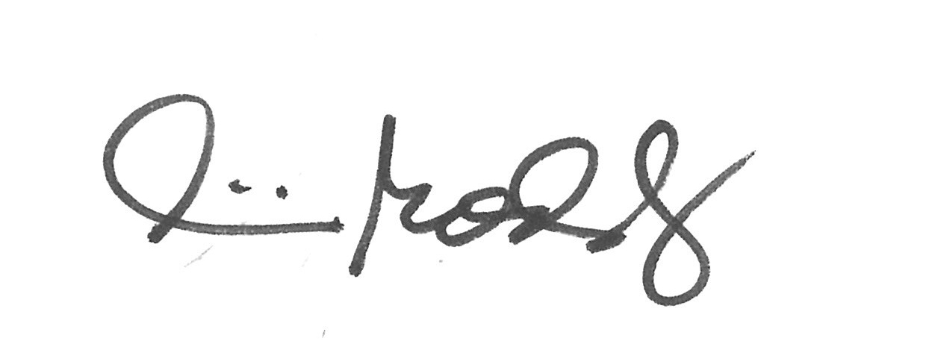
Pat Boddy, P.E.
Partner

