May 25, 2017

Woman Business Owner of the Year Committee
Des Moines Business Publications
100 4th St.
Des Moines, IA 50309

Dear Review Committee,
It has been my honor and privilege to serve with Sara Jacobson as a member and volunteer of the Urbandale Chamber of Commerce and GenYP. Sara has consistently shown leadership in her business, Fusion Boutique. Within the Chamber, she is a Connector, which is the welcoming arm to the Urbandale Chamber. For the last two-years, Sara has earned Best in Class for retail during the Chamber’s Sample Urbandale, A Celebration of Business event.
In addition, Sara gives back to the community. She has volunteered and held fundraisers for other members of the organization including the Lupus Foundation of America Iowa Chapter, Urbandale Food Pantry, Puppy Jake and American Diabetes Association. She is also an active volunteer with Dress for Success where she serves on the Board of Directors and is the co-chair for the Success Luncheon for the organization and has presented during the Going Places Network graduation ceremony for the organization. In addition, she has helped with fundraising efforts for the Des Moines Symphony Club, St. Francis of Assisi, Animal Rescue League, Animal Lifeline of Iowa and Leukemia and Lymphoma Society.
Sara exemplifies professionalism and is talented in all aspects of her career. In addition to running her business and volunteering in the community, she created and developed a new online shopping experience for women called “Wrapped Up”, started a blog called One Chic Lady, mastered the art of scarf tying and now does presentations for women in store, at home and even offices. For all the reasons above, I believe Sara would be a perfect candidate to award with a Woman Business Owner of the Year.
Thank you for your time and consideration.

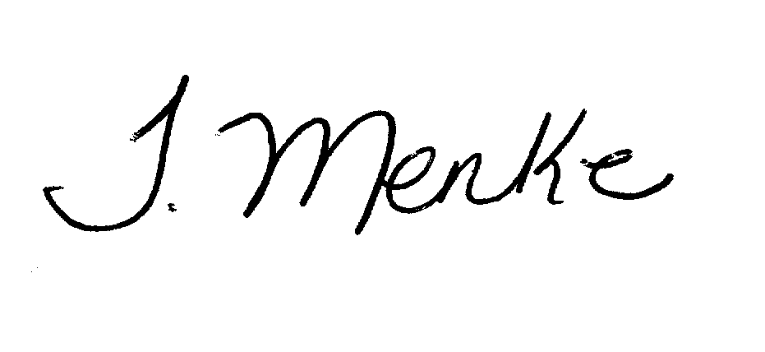
Best Regards,
Tiffany Menke, IOM
President
President
Urbandale Chamber of Commerce

