June 15, 2016

Sages Over 70 Committee

DSM Magazine

100 4th Street

Des Moines, IA 50309

Re: Sages Over 70 — Letter of Support

Dear Committee Members:

It is my pleasure to write a letter in support for The Des Moines Pastoral Counseling Center’s nomination of Ellery Duke, who has been a positive influence on the community for nearly 40 years, as one of the Sages over 70 for 2016.

Although I am a relative newcomer to the Center’s board, I have known Ellery, both personally and professionally, for more than a dozen years. In his quiet, soft-spoken way, he is an inspiration to almost everyone who meets him. His contribution to the Des Moines community in the field of mental health has, in my view, been unparalleled; it is all the more noteworthy given an environment in which financial and legislative support for mental health services has been precarious at best.

Ellery joined the Center in 1977, when it was a cash-strapped counseling service with two-full time therapists. Today, it is a financially stable agency staffed by 26 licensed professionals with expertise in the various facets of mental health services, as well as with a deep appreciation for the value of spirituality in everyday life. Today, the Center offers a broad range of integrated “mind-body-spirit” programs and counseling services to individuals, families, church communities and businesses. Demand for the Center’s programs has expanded steadily under his leadership.

As Chair of the Board, I have worked closely with Ellery over the past year, and have been consistently impressed by his sense of professionalism as well as the spirit of collegiality that pervades the Center. Having been on a number of non-profit boards during my 15 years in Des Moines, I can say, without hesitation, that the Center is one of the most effectively-run and inspiring organizations I have worked with.

Ellery **IS** a sage over 70. I would love to see his wisdom publically recognized.

Respectfully,

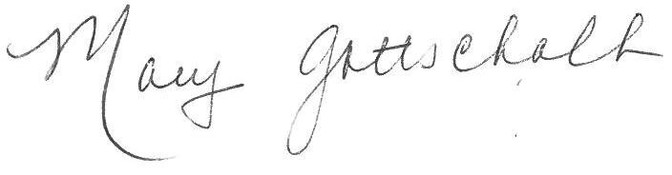

Mary Gottschalk

[mcg9258@gmail.com](mailto:mcg9258@gmail.com)

Chairman of the Board

Des Moines Pastoral Counseling Center