July 1, 2016

Business Record

Sages over 70 Selection Committee

100 4th Street

Des Moines, IA 50309

Dear Selection Committee Members:

It is my honor to write you in support of Joe Brick’s selection for the *Business Record’s* 2016 Sages over 70 Recognition. I feel very qualified to provide a letter of recommendation having known Joe for over 35 years as well as having him serve as General Counsel of ITA Group for over 25 of those years. He is clearly is one of the most dedicated and professional individuals I have ever met and has earned the highest respect from every client he serves as well as everyone who knows him.

While I am certain that there are some very specific attributes and qualities the individual selected must possess - I would to share some of Joe’s having been associated with him. The following truly define Joe Brick:

* Community – Joe lived and raised his family in Urbandale. During a particularly challenging time he ran and was elected Mayor of Urbandale. Joe’s focus was on growing the city’s population and raising its tax base. After serving a successful four year term Joe continued to support the efforts of the city council and mayor.
* Country – Joe has always been committed to our country as demonstrated in his selection as the Civilian Aid to the Secretary of the Army (CASA) representing the State of Iowa. Civilian Aides to the Secretary of the Army were first formally recognized in 1922 and have since become a vital part of the Army. Their mission is to promote good relations between the Army and public by acting as spokespersons for and advisors to the secretary. Joe was committed to bring to Iowans the understanding of the values of the Army, the sacrifices that Soldiers and their families make, and connect the Department of the Army with our communities.
* Demonstrated Leadership – Joe’s areas of focus as an attorney of law have been in Business Law, Healthcare and the representation of Municipalities. He has had long standing relationship with many major corporations in central Iowa and has retained their business as a result of his understanding and commitment to their business. As an example the Des Moines Area Regional Transit (DART) has been a client for over 40 years. Joe was also involved in establishing one of the first Health Maintenance Organizations (HMO’s) in our state as well as the formation of SecureCare, an organization wholly owned by a hospital and it’s physicians as an alternative healthcare delivery system. Many central Iowa communities turned to Joe when they needed guidance on financing, tax and zoning issues. Additionally, he served as a special assistant to the Iowa Attorney General and helped draft legislation on tort reform. Recognition from your peers is one of the most impressive forms of recognition one can received. Joe has consistently been named one of the Best Lawyers in America by those peers.

In closing, it is my sincere hope that you will agree that Joe Brick is a very deserving individual for this important recognition of the Sages over 70 that helped define our community. Joe Brick has excelled in his academic, business and civic endeavors. However, it is also important to point out that he is very humble and grounded for all that he has done and continues to do on behalf of Brick Gentry Law Firm and the community he loves. If there is any additional information I can provide please contact me at your convenience at 515-202-2611.

Respectfully submitted,

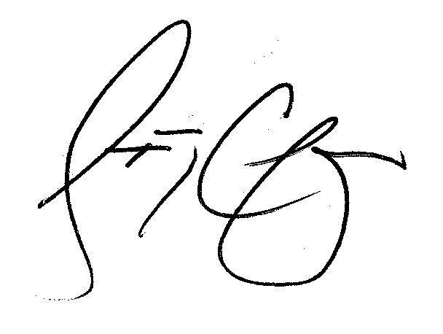

Steven G. Chapman

June 30, 2016

To Whom It May Concern:

This is a strong letter of support for the nomination of Joe Brick for the Business Record’s “Sages Over 70” award.

I can think of no one within the past 30 years of my professional career who could possibly be more worthy of such an award. Joe truly is a sage in every sense of the word, and beyond that he is one of the most kind and considerate human beings to grace the planet. He is a diplomat, a creator, and a visionary.

Please give him the utmost consideration for receipt of this award.

Sincerely,

David D. Coster M.D., FACS

Chairman, Department of Surgery, Grinnell Regional Medical Center

Managing Partner, Surgical Associates LLP of Grinnell